**Regis University**

**Student Documentation**

**Static Database on a Linux Server**

Table of Contents

Connecting to Oracle using Citrix on RegisNet 6

Open SQL*Plus 6

Connect to the regisdb or regisdb12c database 8

Working with Student Files 10

Contact DBA Help Desk 14

**Using Citrix on RegisNet**

1. Open Internet Explorer and go to the following URL:  
   <http://myregisapp.regis.edu/Citrix/StoreWeb/>
2. Enter your Regisnet creditials as shown below and then click Log On.

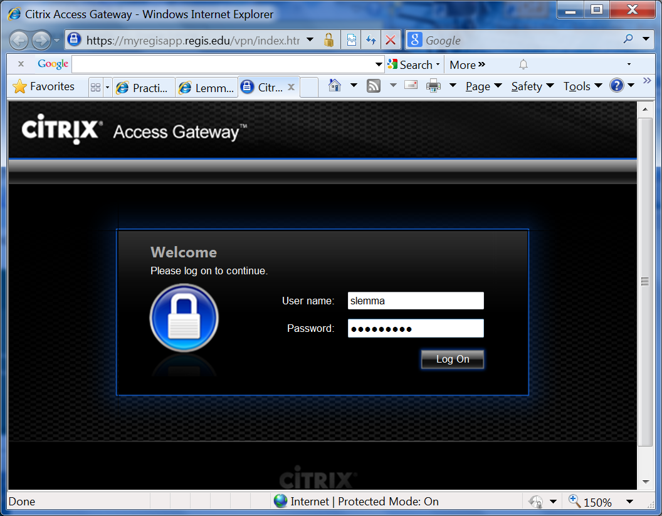

Username: your student ID (regis.net ID)

Password: your student password

1. Click on the plus sign to add applications/Add Apps as shown below .

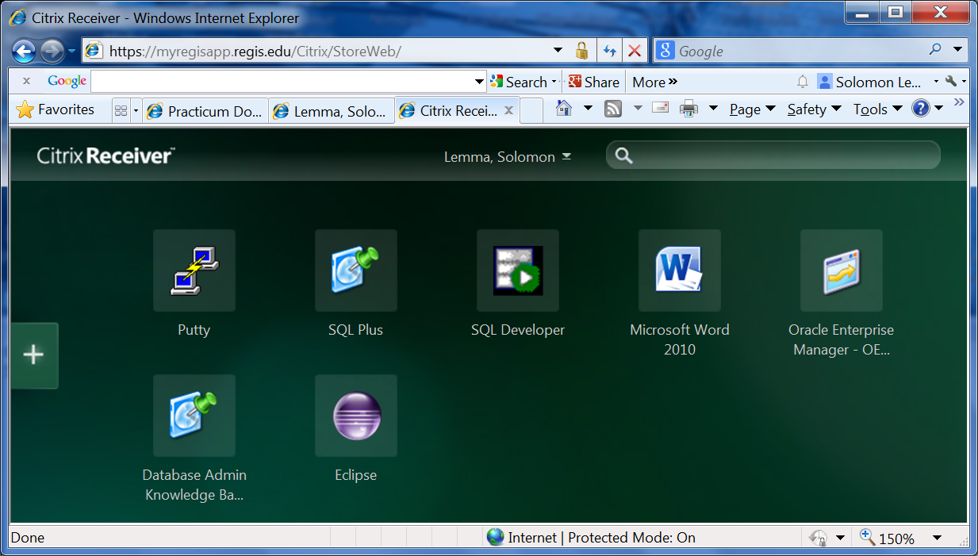

1. On the left hand side of the screen, a window will appear (as shown below).

Click on the All Apps to display all of the available applications.

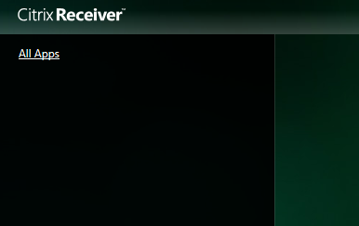

1. The list of available applications for your new custom desktop will be listed (as shown below).

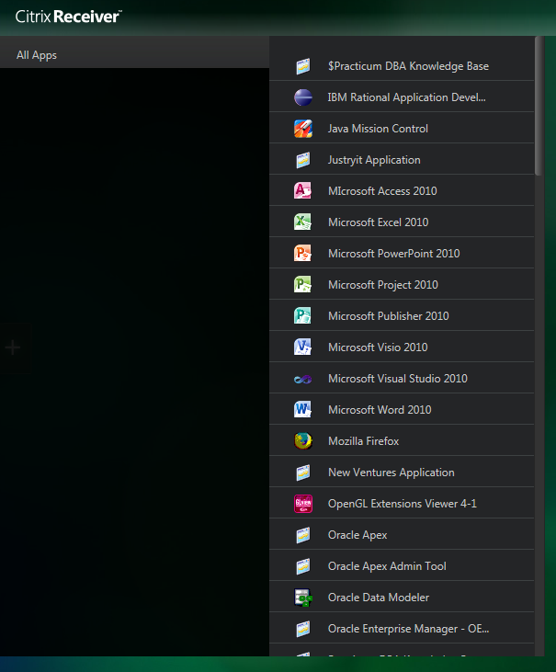

1. To place an application on your desktop, simply left mouse click on the application name and it will move automatically to your desktop. In the example (shown below), the putty application was left mouse clicked and it moved to the desktop (as indicated by the green check mark next to the putty name in the master list). Continue this process until you have moved all of the application you need to the desktop.

Note: If you accidentally pick an application that you do not want on your desktop, then right mouse click on the application on your desktop. This will give you popup menu that will allow you to remove the application from your desktop and it will be returned to master list of available application.

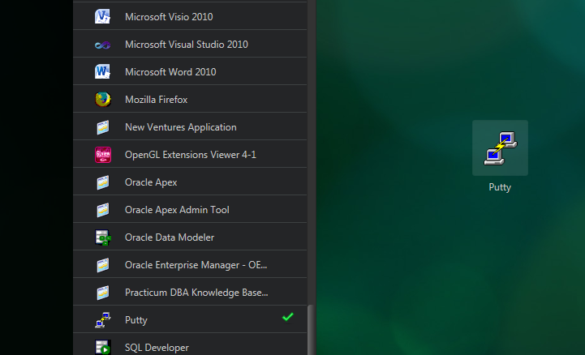

If you have issues logging in please contact the help desk at [dbahelp@regis.edu](mailto:dbahelp@regis.edu) and notify your instructor.

# Connecting to Oracle using Citrix on RegisNet

## Open SQL*Plus

1. Navigate to <http://myregisapp.regis.edu/Citrix/StoreWeb/> and connect to Citrix using your Citrix username and password
2. Once logged in click on Plus sign 🡪 All Apps🡪 SQL Plus 🡪 left click (will automatically move to desktop)

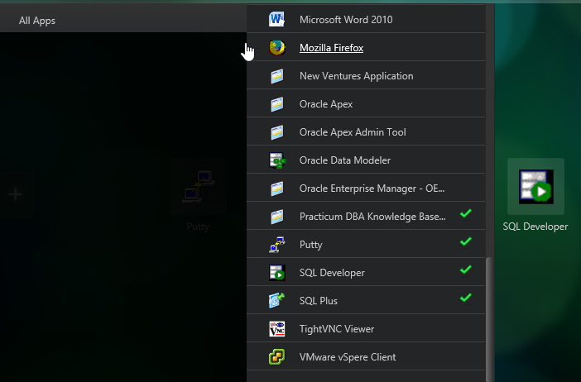

Figure 1 – SQL Plus

1. In the example (below), I have added the following apps to my desktop: SQL Plus, Putty, Practicum DBA Knowledgebase, SQL Developer, etc.
2. For the next step move the mouse to the desktop, then click on the SQL Plus icon on your desktop as shown below (see red arrow). After you click the SQL Plus icon, you will see a popup box that shows that SQL Plus is starting…

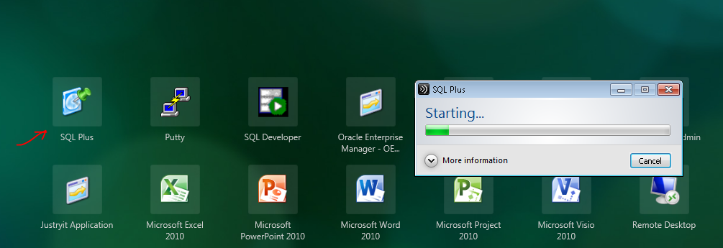

Figure 2 - Citrix Applications

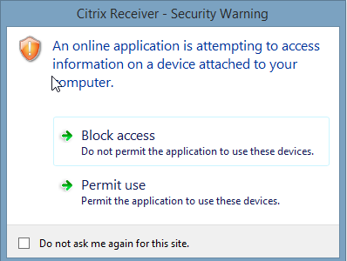

Figure 3 - Client Access – if you get this popup box, click the box “Do not ask me again for this site” and then click on permit use.

## Connect to the regisdb or regisdb12c database

1. Use the username and password provided by your instructor to connect to SQL Plus.
   1. User Name- Enter the user name provided by your instructor and database name (see example below in yellow). <username>@<database name>
   2. Password- Enter the password provided by your instructor. Note that the password will not display or cursor will not move as you type, however it will accept the password and let you login to SQL*Plus.
      1. As a general rule the database password will be either regis8wk1 or regis8wk2, depending on which part of the semester you are currently enrolled.

Example:

For 12c

Username: mscd600xp40_01@regisdb12c

Enter password when prompted

For 11g

Username: mscd600xp40_01@regisdb

Enter password when prompted

Figure 4 - SQL*Plus Login

1. Once you are connected to a SQL Plus session and at the SQL prompt, type in the following: SELECT SYSDATE FROM DUAL;  
   This should display the system date as in the screen shot below:

Figure 5 - SQL*Plus example

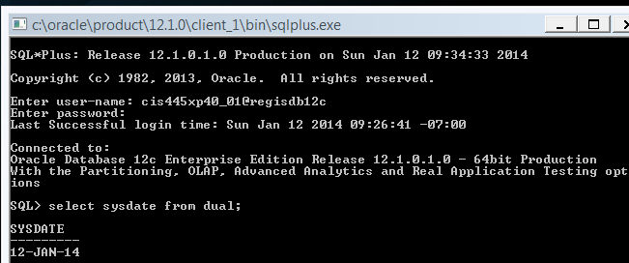**Contact DBA Help Desk**

If you have any problems, questions or require additional information, please contact: [dbahelp@regis.edu](mailto:dbahelp@regis.edu)

IMPORTANT: To expedite response times, make sure to include your Citrix login/password and Oracle login/password in the email. Additionally, please provide any relevant error messages and a brief description of what you were trying to do when you encountered the problem.

Note: The DBA help desk is staffed daily. Please allow for 4 hours for all initial responses for new requests. All requests will be answered in the order they are received.

**Useful Resources**

The Regis Database Help Desk is posting to Twitter. If you get a twitter account, and subscribe to DBAHELP, you will be informed of outages, daily database check, and important tips or informational items.

Accounts can be created/accessed at: [www.twitter.com](http://www.twitter.com/)